Unit 9: Exponentials
Lesson 2: Bank Investments Simple vs Compound
Objectives:
- I understanding the different banking investment options
- I can evaluate the amount of money generated from using different investment options
- I can write and evaluate exponential functions

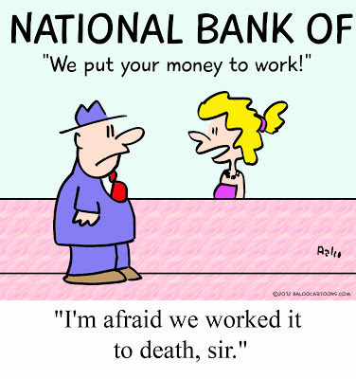
Agenda:
- Banking and investment options
- Practice investment problems

Focus Questions:
- What is Simple interest and compounded interest?
- Which banking investment option generates more money?
- How can I calculate the amount of money I can make from these investment options?

Vocabulary:
- Simple interest
- Compounded interest

Homework: HW 9-2
Videos for Simple interest only:
https://www.youtube.com/watch?v=xRiOex8CBD0
https://www.youtube.com/watch?v=ZWCXrbnMN-E

Quiz on lesson 1 and 2 in two blocks.

Warm up:
- The value of Jim’s investment is increasing by 4% each year. If his initial investment is $1250.35, determine the following:
Write an equation which could be used to determine the total value of his investment after x years. Remember: In the exponential equation , a is the starting value and b is the growth/decay ratio.

  - Use your equation to determine the total value of his investment after 50 years algebraically.

  - Graphically determine when his investment will be worth 20,000. Sketch

- A two-bedroom house in Nashville is worth $110,000. If it depreciates at 2.5% per year, when will it be worth $50,181?

3)
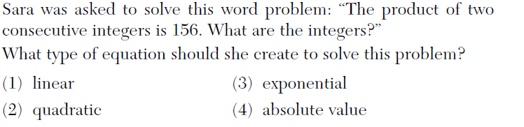
4)
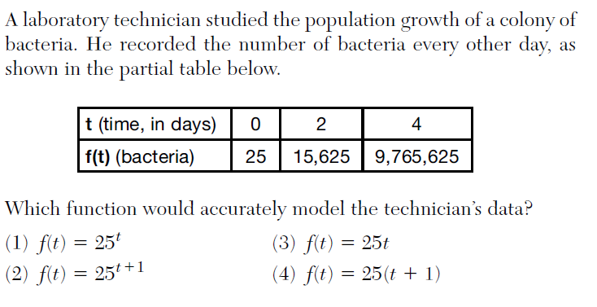
5)
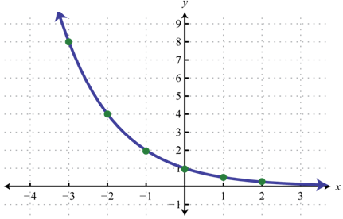
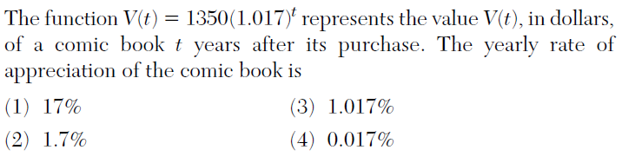
6) Write a table of value for the graph

b. What is the average rate of change over $-3≤x≤-1$?

2. The population of Bridgeville, PA, is 5300 with a growth rate of 1.3% per year.
a. Explain what 5300 and 1.3% mean in this context of the problem:

b. Does the problem depict a growth or a decay factor? Why?

C. Write a function to model the number of people y after x number of years.

Notes: Compound interest and money.
Banks pay customers interest to look after their money. When you invest your money in a bank, you have many investment options that you can choose from. In banking the starting amount of money is usually called the principal and donated by (P). (A) is the final balance, (r) is the interest rate, and (n) is the number of times the money compounded.
Most Banks offer the following investment account options for their customer
Type of interest | Value of n | Formula used
Simple Interest – Interest is calculated once per year on the original amount borrowed or invested. The interest does not become part of the amount borrowed or owed (the principal). | N/A | $$A=P\left(1+rt\right)$$
Compound Interest – Interest is calculated once per period on the current amount borrowed or invested. Each period, the interest becomes a part of the principal.  Money can be compounded: |  | $${A=P(1+\frac{r}{n})}^{nt}$$
Yearly | n=1
Quarterly | n=4
Monthly | n=12
Daily | n=365
Weekly | n=52
Examples:
- Dylan invested $600 in a savings account at a 1.6% annual interest rate. He made no deposits or withdrawals on the account for 2 years. The interest was compounded annually. Find, to the nearest cent, the balance in the account after 2 years to the nearest cent.

Videos for Compound interest only: Pause each video and try the problems yourself.
https://www.youtube.com/watch?v=ppBi3TN9D10
https://www.youtube.com/watch?v=N_zOA5Gjcy8
2)Caroline deposited $1500 in an account that pays 4% interest compounded quarterly (n = 4). What will the balance be in 2 years TO THE NEAREST CENT?

3)Mike have $12,000 in a savings account. The bank pays 3.5% interest on savings accounts, compounded monthly (n = 12). Find the total balance after three years TO THE NEAREST DOLLAR.

Ready to compare which is a better deal?
- Lily has been babysitting since 8th grade. She has saved $1,254.67 and wants to open an account at the bank so that she will earn interest on her savings. One Bank pays simple interest at a rate of 13.5% annually. A second bank offers a weekly compound interest at a rate of 5.25%. Which bank offers a better deal for Lily if she want to invest the money for 5 years? Round to the nearest cent.
Simple Interest Formula: | Compound interest Formula:

Conclusion:

Homework: _____________ Name: _____________ Date: _________
1).If $5000 is invested at a rate of 3% interest compounded quarterly, what is the value of the investment in
5 years? (Use the formula 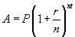where A is the amount accrued, P is the principal, r is the interest rate, n is the number of times per year the money is compounded, and t is the length of time, in years.)
- $5190.33
- $5796.37
- $5805.92
- $5808.08

- Mike have $12,436 in a savings account. The bank pays 3.25% interest on savings accounts, compounded monthly (n = 12). Find the total balance after three years TO THE NEAREST DOLLAR.

- Courtney opens a savings account by depositing $1265.15 in an account that earns 2.75% interest compounded quarterly. How much will her investment be worth in 10 years?

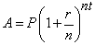
- Yosef deposits $50 into a savings account that pays 3.25% interest compounded quarterly. The amount, A, in his account can be determined by the formula , where P is the initial amount invested, r is the interest rate, n is the number of times per year the money is compounded, and t is the number of years for which the money is invested. What will his investment be worth in 12 years if he makes no other deposits or withdrawals? Must show all work!
1.$55.10
- $73.73
- $232.11
- $619.74
- Daniella has been babysitting since68th grade. She has saved $1435 and wants to open an account at the bank so that she will earn interest on her savings. One Bank pays simple interest at a rate of 3% annually. A second bank offers a weekly compound interest at a rate of 2%. Which bank offers a better deal for Daniella if she want to invest the money for 4 years? Round to the nearest dollar.
Simple Interest Formula: | Compound interest Formula:

Review questions:
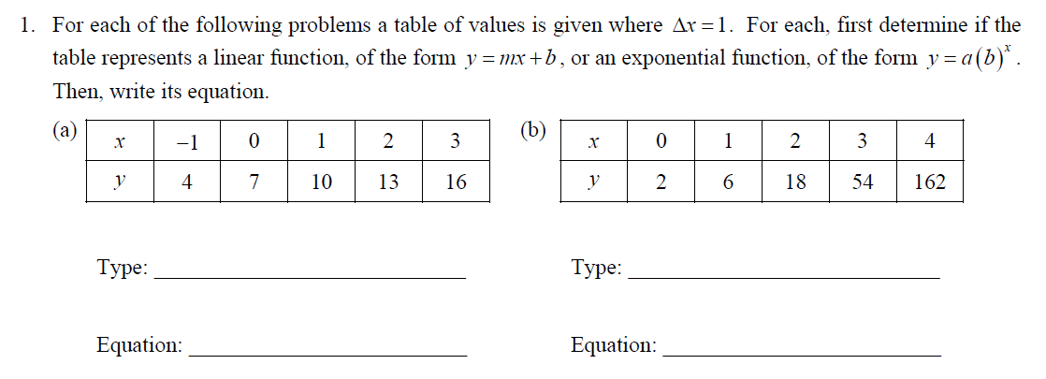

Factor: $A) 49x^{2}-100$ B) $-3x^{3}-21x$

C) ${ 64x}^{2}-9$ D) ${81x}^{4}-16$

